**COMPILED LIST OF ISSUES ENCOUNTERED IN exploration.ipynb NOTEBOOK (from** [**here**](https://github.com/NASA-IMPACT/hls-foundation-os)**)**

**General:**

* Why does [this page](https://github.com/NASA-IMPACT/hls-foundation-os/tree/main/fine-tuning-examples) no longer exist/can we get access to these example notebooks

**Dependency errors:**

* Most modules no longer exist/have been renamed
* **from model_inference import inference_segmentor, process_test_pipeline** has been the main blocker

**Execution errors (in order they appear in notebook):**

* Cropping error which occurs only on some tif images. Occurs with load_raster function. This issue does not occur when the crop parameter is removed (error screenshot below)
* 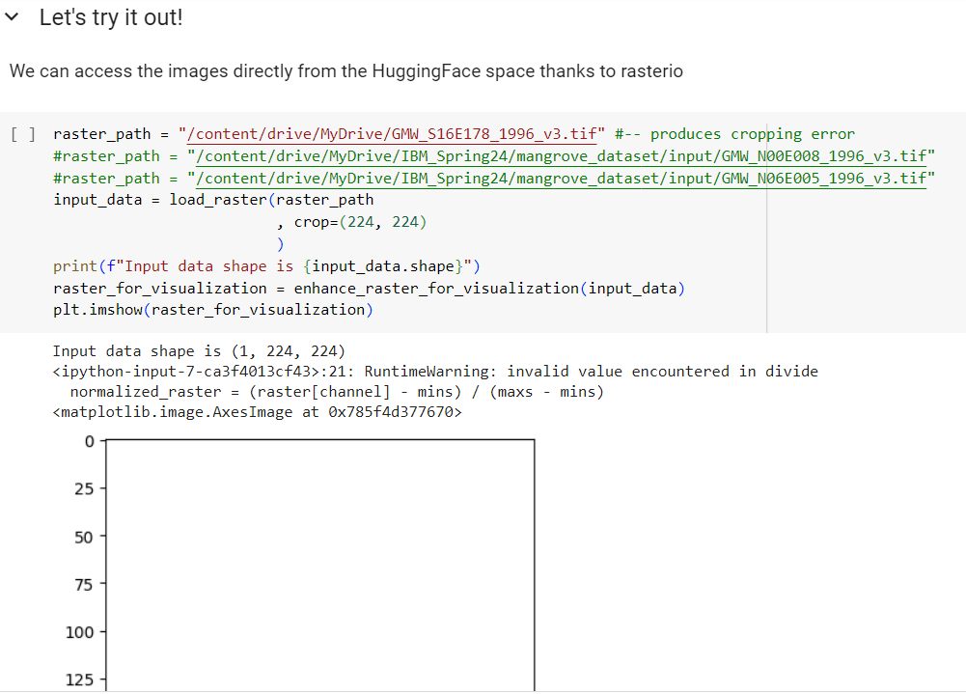
* Issue with plot_image_mask_reconstruction function. Is it because our input data is not of good quality? (error screenshot below)
* 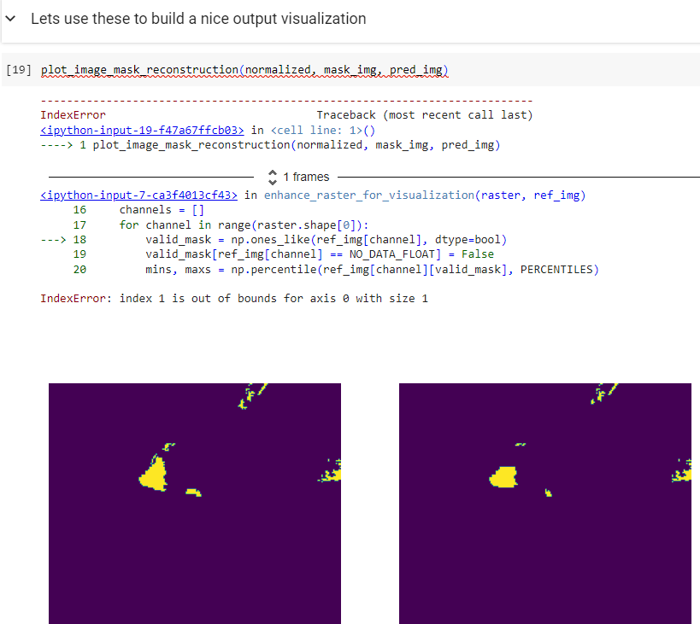

**Running command line prithvi commands (examples below):**

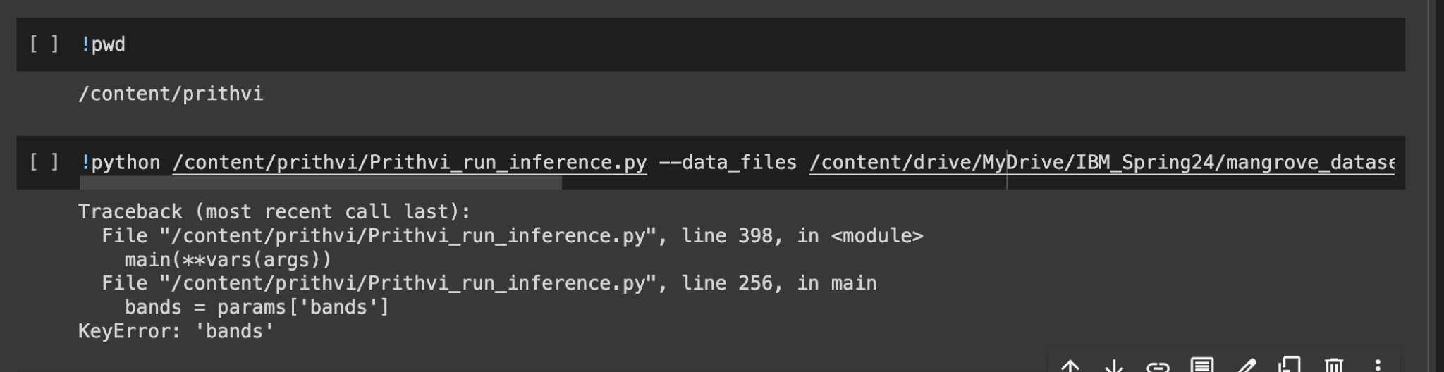

YAML file for reference:

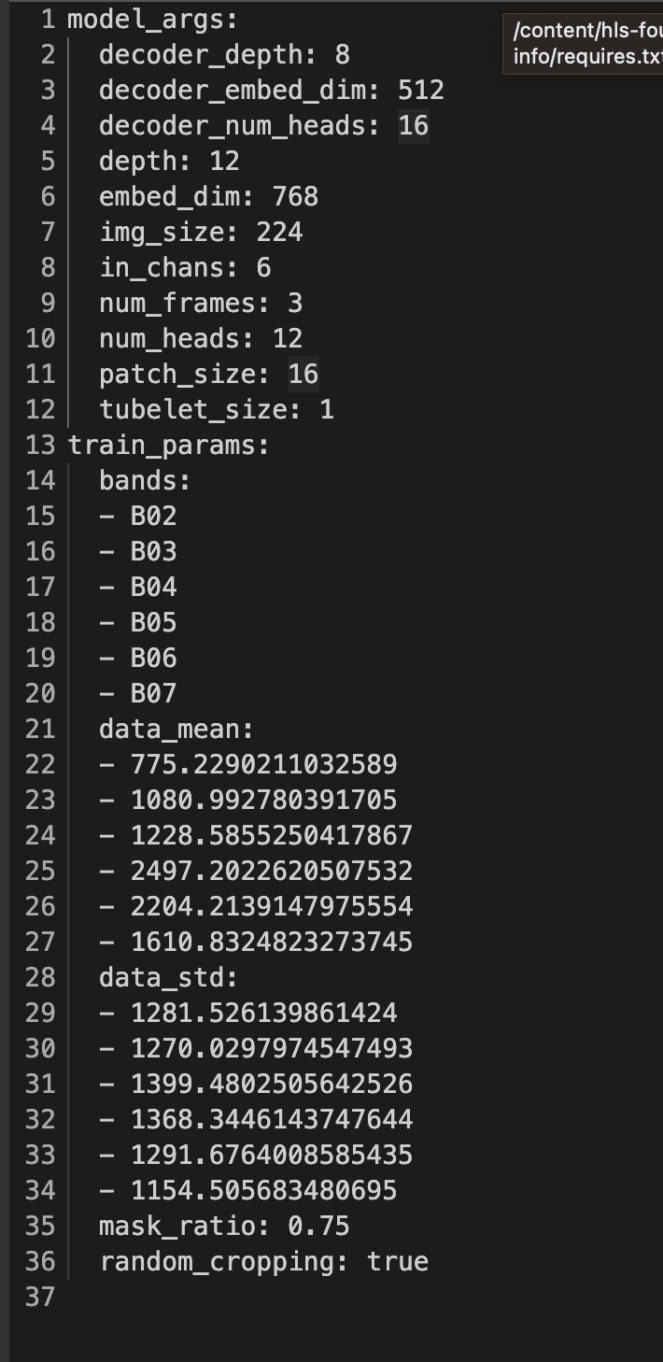

**Initializing model error**:



Produces error due to inability to import custom packages from geospatial_fm (downloaded git repo for geospatial_fm before running code snippet, however)